Аннотация

Учитель английского языка Гаврильченко Светлана Александровна представляет работу ученика 9 А класса Романова Дмитрия , победителя школьной научно – практической конференции 2011 – 2012 учебного года , секции «Английский язык», участника VI научно – практической конференции научного округа «Отрадное» 2011 – 2012 учебного года.

Муниципальное бюджетное общеобразовательное учреждение

Одинцовская гимназия №7

Реферат на тему: «New Zealand»

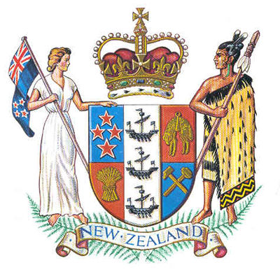

Выполнил

Ученик 9 «А» класса

Романов Дмитрий Петрович

Учитель: Гаврильченко Светлана Александровна

г.Одинцово

Plan: 1) New Zealand

1a) Location

1b) Size

2) National coat

2a) United Kingdom

2b) Dominion

3)National emblem

3a) Weight

3b) Species

3c) Behavior

3d) Attributes

4) Discoverers

4a) James Cook

4b) Maori

4c) Abel Tasman

5) Cities and islands included in the New Zealand

5a) Total area

5b) The population

6)Birds

6a) Many species of birds

7)Plants

7a) Bio-diverse flora area

7b) Native trees

8)Animals

**1) New Zealand.**

**The aim of my work is to describe the geographical position of New Zealand and its flora and fauna.**

**The main idea of this presentation is to make people a bit more familiar with New Zealand itself.**

New Zealand is an island country located in the southwestern Pacific Ocean. The country geographically comprises two main landmasses ‒ that of the North and South Islands ‒ as well as numerous smaller islands. New Zealand is situated some 1,500 kilometers (900 mi) east of Australia across the Tasman Sea and roughly 1,000 kilometers (600 mi) south of the Pacific island nations of New Caledonia, Fiji, and Tonga. Because of its remoteness, it was one of the last lands to be settled by humans.

[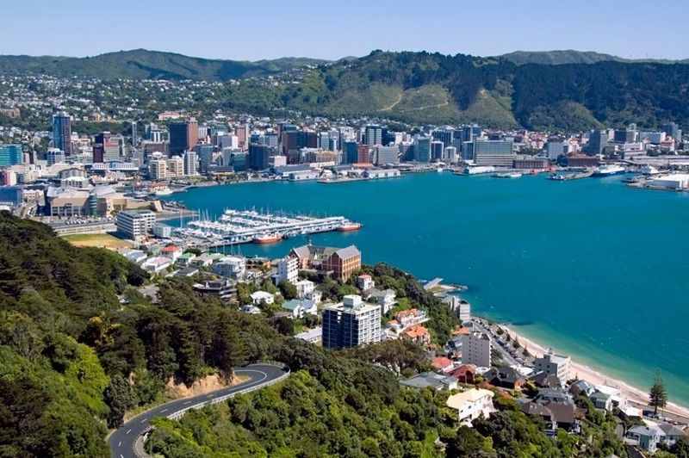](http://s3-eu-west-1.amazonaws.com/youroute-main/home/ubuntu/production/public/ckeditor_assets/pictures/27170/content_.jpg.?1323257743)During its long isolation,New Zealand developed a distinctive biodiversity of both animal and plant life.

Most notable are the large number of unique bird species, many of which became extinct after the arrival of humans and introduced mammals. With a mild maritime climate, the land was mostly covered in forest.

The country's varied topography and its sharp mountain peaks owe much to the tectonic uplift of land and volcanic eruptions caused by the Pacific and Indo-Australian Plates clashing beneath the earth's surface.

New Zealand is long (over 1,600 kilometres (990 mi) along its north-north-east axis) and narrow (a maximum width of 400 kilometres (250 miwith approximately 15,134 km (9,404 mi) of coastline and a total land area of 268,021 square kilometres (103,483 sq mi) Because of its far-flung outlying islands and long coastline, the country has extensive marine resources. Its Exclusive Economic Zone, one of the largest in the world, covers more than 15 times its land area.

The South Island is the largest land mass of New Zealand, and is divided along its length by the Southern AlpsThere are 18 peaks over 3,000 metres (9,800 ft), the highest of which is Aoraki/Mount Cook at 3,754 metres (12,316 ft). Fiordland's steep mountains and deep fiords record the extensive ice age glaciation of this south-western corner of the South Island. The North Island is less mountainous but is marked by volcanism. The highly active Taupo volcanic zone has formed a large volcanic plateau, punctuated by the North Island's highest mountain, Mount Ruapehu (2,797 metres (9,177 ft)). The plateau also hosts the country's largest lake, Lake Taupo, nestled in the caldera of one of the world's most active supervolcanoes.

The country owes its varied topography, and perhaps even its emergence above the waves, to the dynamic boundary it straddles between the Pacific and Indo

Australian Plates. New Zealand is part of Zealandia, a microcontinent nearly half the size of Australia that gradually submerged after breaking away from the Gondwanan supercontinent. About 25 million years ago, a shift in plate tectonic movements began to contort and crumple the region. This is now most evident in the Southern Alps, formed by compression of the crust beside the Alpine Fault. Elsewhere the plate boundary involves the subduction of one plate under the other, producing the Puysegur Trench to the south, the Hikurangi Trench east of the North Island, and the Kermadec and Tonga Trenches further north.

**2) National coat.**

The coat of arms of New Zealand is the official symbol of New Zealand. The initial coat of arms was granted by King George V on the 26 August 1911, and the current version was granted by Queen Elizabeth II in 1956.

Until 1911, New Zealand used the same national coat of arms as the United Kingdom. When New Zealand became a Dominion in 1907, it was decided that a new Coat of Arms was required, and a design competition was held. The winning entry was a design by James McDonald, a draughtsman in the Department of Tourist and Health Resorts. Since being granted its own arms in 1911, New Zealand's arms have remained similar to the current design, with minor changes in 1956.

Since 1911, the central shield has remained unaltered: a quartered shield containing in the first quarter four stars representing the Southern Cross constellation, as depicted on the national flag, but with the stars in different proportions; in the second quarter, a golden fleece representing the farming industry; in the third, a wheat sheaf representing agriculture; and in the fourth, two hammers representing mining and industry. Over all this is a pale, a broad vertical strip, with three ships representing the importance of sea trade, and the immigrant nature of all New Zealanders.

Before 1956, the shield was identical, but the surrounding features were different. The crest was a demi-lion (the upper half of a rampant lion) holding the British Union Flag, and the scroll at the shield's base featured the then motto of the country, "Onward". Early renditions of the Coat of Arms are often featured with more stylised scrolling rather than fern leaves.

The original supporters were also slightly different. The woman had reddish-brown hair, and both figures faced forward rather than towards the shield. Though there is no direct documentary evidence, it is likely that the original model for the woman was Wellington socialite Alice Spragg. The model for the Māori warrior is unknown.

**3)National emblem.**

The kiwi bird was named so for the sound of its chirp. This flightless bird, about the size of a domestic hen, has an extremely long beak and plumage more like hair than feathers. It has no tail, almost no wings. It weighs about 2 kg. The female kiwi lays only one egg, but it is about 1/5th of her own weight. After laying it she leaves her husband to hatch the egg out.

[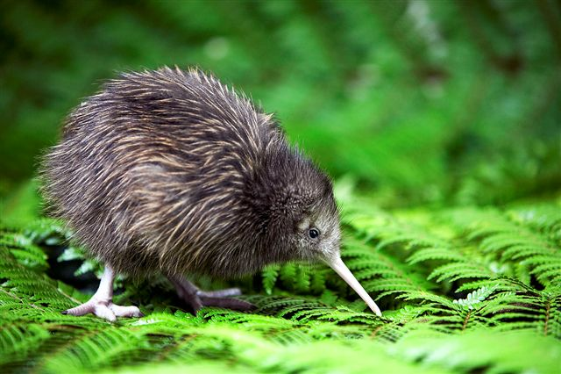](http://www.bbh.co.nz/associateImages/im_147_RS003-04.jpg)The New Zealand dollar is frequently called the Kiwi. During the First World War, the name "kiwi" for New Zealand soldiers came into general use, and a giant kiwi (now known as the Bulford Kiwi), was carved on the chalk hill above Sling Camp in England. Use has now spread so that now all New Zealanders overseas and at home are commonly referred to as "kiwis".

The kiwi has since become the most well-known national symbol for New Zealand, and the bird is prominent in the coat of arms, crests and badges of many New Zealand cities, clubs and organizations; at the national level, the red silhouette of a kiwi is in the center of the roundel of the Royal New Zealand Air Force

The New Zealand dollar is often referred to as "the kiwi dollar".

The kiwi is the sole survivor of an ancient order of birds including the now extinct moas. A flightless bird about the size of a domestic fowl, the kiwi has coarse, bristly, hair-like feathers. Females are larger than males.

Kiwis grow to about the size of a chicken and weigh between three and nine pounds. They have no tail and tiny two inch wings which for all practical purposes, are useless. Despite its awkward appearance, a kiwi can actually outrun a human and have managed to survive because of their alertness and their sharp, three-toed feet, which enable them to kick and slash an enemy.

The kiwi’s long slender bill has nostrils at the lower end. Using its excellent sense of smell and flexible bill, the kiwi feeds on worms, insects and grubs, supplemented by leaves, berries and seeds. There are five kinds of kiwi in New Zealand - three closely related... Brown Kiwis, the Little Spotted Kiwi and the Great Spotted Kiwi... are pictured at the bottom of the page.

The young kiwi emerges wearing shaggy adult plumage. The young chick is not fed by the adult, but survives on a large reserve of yolk in its belly. Gaining strength, the chick remains in the nest for six to ten days. The young kiwi then leaves the burrow, and, accompanied by the male, begins to search for food. Kiwis have been known to live up to twenty years.

Today, New Zealanders overseas (and at home) are still invariably called “Kiwis”. The Kiwi is still closely associated with the Armed Forces. The New Zealand dollar is often referred to as the “The Kiwi” and the kiwi fruit is known as a “Kiwi” in some countries. Kiwis feature in the coat of arms, crests and badges of many New Zealand cities, clubs and organisations.

**4)Discoverers**

New Zealand is one of the most recently settled major land masses. The first settlers of New Zealand were Eastern Polynesians who came to New Zealand, probably in a series of migrations, sometime between around AD 800 and 1300. Over the next few centuries these settlers developed into a distinct culture now known as Māori.The first Europeans known to have reached New Zealand

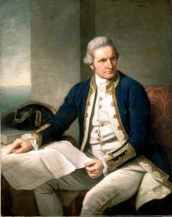 The first Europeans known to have reached New Zealand Zealand were Dutch explorer Abel Tasman and his crew in 1642. Any thoughts of a longer stay were thrown away when hi attempt to land resulted in several of his crew being killed and eaten by Maori.

No Europeans returned to New Zealand until British explorer James Cook`s voyage of 1768. Following Cook, New Zealand was visited by numerousEuropean and North America whaling, sealing and trading ships. They traded European food and goods, especially metal tools and weapons, for Maori timber, food, artifacts and water.

**5) Cities and islands included in New Zealand**

North Island

The North Island (Māori: Te Ika-a-Māui) is one of the two main islands of New Zealand, separated from the slighty larger but much less populous South Island by Cook Strait. The island is 113,729 square kilometres (43,911 sq mi) in area, making it the world's 14th-largest island. It has a population of 3,366,100 (June 2011 estimate).

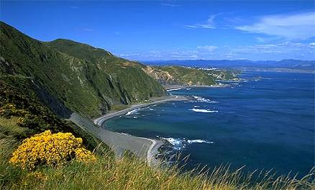Twelve cities are in the North Island: Auckland, New Plymouth, Tauranga, Gisborne, Napier, Hamilton, Hastings, Palmerston North, Rotorua, Wanganui, Whangarei and Wellington, the capital, located at the southern extremity of the island. Approximately 76% of New Zealand's population lives in the North Island.

Although the island has been known as the North Island for many years, the New Zealand Geographic Board has found that, along with the South Island, it has no official name. The board intends to make North Island the island's official name, along with an alternative Māori name. Although several Māori names have been used, Maori Language Commissioner Erima Henare sees Te Ika-a-Māui as the most likely choice.

The definite article is used with the names of the North and South islands, as the North Island and the South Island, like the North Sea and the Western World, but unlike Rangitoto Island or West Point. Maps, headings or tables and adjectival expressions use North Island, whereas the North Island is used after a preposition or before or after a verb, e.g. my mother lives in the North Island, the North Island is smaller than the South Island, or I'm visiting the North Island. When specifying that the island is where a place, person, or object is located, it is normal to use the word in rather than on, for example Hamilton is in the North Island.

Wellington

Wellington is the capital city and second most populous urban area of New Zealand. It is at the southwestern tip of the North Island, between Cook Strait and the Rimutaka Range. It is home to 393,400 residents.

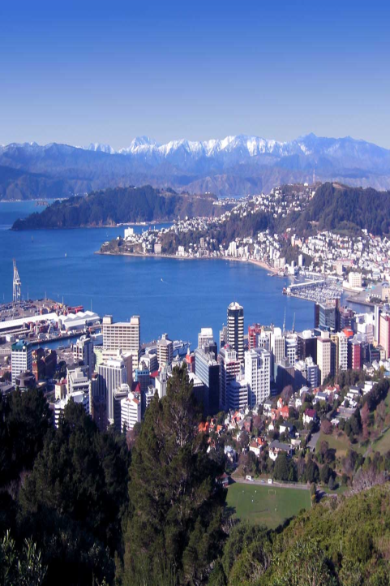The Wellington urban area is the major population centre of the southern North Island, and is the seat of the Wellington Region – which in addition to the urban area covers the Kapiti Coast and Wairarapa. The urban area includes four cities: Wellington, on the peninsula between Cook Strait and Wellington Harbour, contains the central business district and about half of Wellington's population; Porirua on Porirua Harbour to the north is notable for its large Māori and Pacific Island communities; Lower Hutt and Upper Hutt are largely suburban areas to the northeast, together known as the Hutt Valley. Wellington also holds the distinction of being the worlds most southerly capital city.

Wellington is New Zealand's political centre, housing Parliament, the head offices of all Government Ministries and Departments and the bulk of the foreign diplomatic missions in New Zealand.

Wellington's compact city centre supports an arts scene, café culture and nightlife much larger than many cities of a similar size. It is an important centre of New Zealand's film and theatre industry, and second to Auckland in terms of numbers of screen industry businesses.Te Papa Tongarewa (the Museum of New Zealand), the New Zealand Symphony Orchestra, the Royal New Zealand Ballet, Museum of Wellington City & Sea and the biennial New Zealand International Arts Festival are all sited there.

European settlement began with the arrival of an advance party of the New Zealand Company on the ship Tory, on 20 September 1839, followed by 150 settlers on the Aurora on 22 January 1840. The settlers constructed their first homes at Petone (which they called Britannia for a time) on the flat area at the mouth of the Hutt River. When that proved swampy and flood-prone they transplanted the plans, which had been drawn without regard for the hilly terrain.

New Zealand's capital

In 1865, Wellington became the capital city of New Zealand, replacing Auckland, where William Hobson had placed the capital in 1841. The Parliament of New Zealand had first met in Wellington on 7 July 1862, on a temporary basis, but Wellington did not become the official capital city for three more years. In November 1863, the Prime Minister of New Zealand, Alfred Domett, places a resolution before Parliament (meeting in Auckland) that "... it has become necessary that the seat of government ... should be transferred to some suitable locality in Cook Strait [region]." Apparently, there had been some concerns that the more highly populated South Island (where the goldfields were located) would choose to form a separate colony in the British Empire. Several Commissioners invited from Australia (chosen for their neutral status to help resolve the question) declared that Wellington was a suitable location because of central location in New Zealand and its good harbour. Parliament officially met in Wellington for the first time on 26 July 1865. At that time, the population of Wellington was just 4,900.

As the national capital, Wellington is the location of the highest court of New Zealand, the Supreme Court. The historic former High Court building has been enlarged and restored for the use of the Supreme Court.

Population

The four cities have a total population of 294,300), and the Wellington urban area contains 99% of that population. The remaining areas are largely mountainous and sparsely farmed or parkland and are outside the urban area boundary.

Hamilton

Hamilton is the country's 7th largest city. The population is 187, 960 people. It is in the Waikato region of the North Island. It sits on both banks of the Waikato River. The city is host to a large number of small galleries and the Waikato Museum. Hamilton is home to more than 25,000 students, mostly enrolled in one of the city's two main institutes, the University of Waikato and Waikato Institute of Technology.

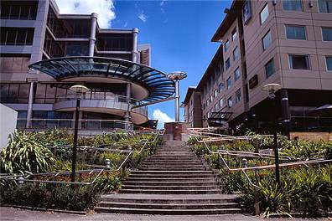Hamilton is the centre of New Zealand's fourth largest urban area, and Hamilton City is the country's fourth largest territorial authority. Hamilton is in the Waikato Region of the North Island, approximately 130 km (80 mi) south of Auckland. It sits at a major road and rail nexus in the centre of the Waikato basin, on both banks of the Waikato

Initially an agricultural service centre, it now has a growing and diverse economy and is the second fastest growing urban area in New Zealand. Education and research and development play an important part in Hamilton's economy, as the city is home to approximately 40,000 tertiary students and 1,000 PhD scientists.

Taranga

Taranga is the largest city of the Bay of Plenty region. The Population is about 109,100 people. It is the 9th largest city area in the country, and the centre of the 6th largest urban area.

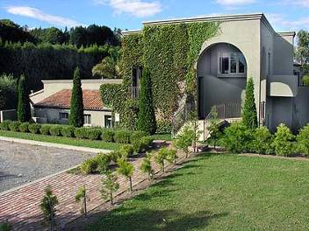Tauranga is the most populous city in the Bay of Plenty region, in the North Island of New Zealand.

It was settled by Europeans in the early 19th century and was constituted as a city in 1963. Tauranga City is the centre of the sixth largest urban area in New Zealand, with an urban population of 121,500 (June 2011 estimate).

The city lies in the north-western corner of the Bay of Plenty, on the south-eastern edge of Tauranga Harbour. The city expands over an area of 168 square kilometres (65 sq mi), and encompasses the communities of Bethlehem, on the south-western outskirts of the city; Greerton, on the southern outskirts of the city; Matua, west of the central city overlooking Tauranga Harbour; Maungatapu; Mount Maunganui, located north of the central city across the harbour facing the Bay of Plenty; Otumoetai; Papamoa, Tauranga's largest suburb, located on the Bay of Plenty; Tauranga City; Tauranga South; and Welcome Bay.

Tauranga is one of New Zealand's main centres for business, international trade, culture, fashion and horticultural science. The Port of Tauranga is New Zealand's largest port in terms of gross export tonnage.

Tauranga is one of New Zealand's fastest growing cities, with a 14 percent increase in population between the 2001 census and the 2006 census.

Rotorua

Rotorua is a town on the southern shore of Lake Rotorua in the Bay of Plenty region. The city has a population of 53,000, of which one third is Māori. Rotorua is well-known for geothermal activity. There are a number of geysers, notably the Pohutu geyser at Whakarewarewa, and hot mud pools located in the city, which owe their presence to the Rotorua caldera.

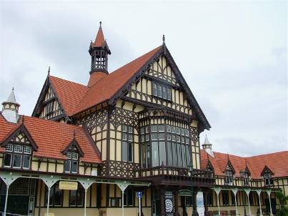Rotorua is a city on the southern shores of the lake of the same name, in the Bay of Plenty region of the North Island of New Zealand. The city is the seat of the Rotorua District, a territorial authority encompassing the city and several other nearby towns. Rotorua city has an estimated permanent population of 56,200, with the Rotorua district having a total estimated population of 68,900. The city is in the heart of the North Island, just 60 kilometres (37 mi) south of Tauranga, 80 kilometres (50 mi) north of Taupo, 105 kilometres (65 mi) east of Hamilton, and 230 kilometres (140 mi) southeast of the nation's most populous city, Auckland.

Rotorua is a major destination for both domestic and international tourists; the tourism industry is by far the largest industry in the district. The city is known for its geothermal activity, and features geysers – notably the Pohutu Geyser at Whakarewarewa – and hot mud pools. This thermal activity is sourced to the Rotorua caldera, on which the city lies. Rotorua is home to the Waiariki Institute of Technology.

South island

The South Island is the larger of the two major islands of New Zealand, the other being the more populous North Island. It is bordered to the north by Cook Strait, to the west by the Tasman Sea, to the south and east by the Pacific Ocean. The territory of the South Island covers 151,215 square kilometres (58,384 sq mi) and is influenced by a temperate climate.

The South Island is sometimes called the "Mainland". While it has a 33% larger landmass than the North Island, only 24% of New Zealand's 4.4 million inhabitants live in the South Island. In the early stages of European (Pākehā) settlement of the country, the South Island had the majority of the European population and wealth due to the 1860s gold rushes. The North Island population overtook the South in the early 20th century, with 56% of the population living in the North in 1911, and the drift north of people and businesses continued throughout the century.

The South Island is the larger of the two major islands of New Zealand. The South Island has an area of 151,215 sq. km, making it the world's 12th-largest island. It has a population of 991,100. Along its west coast runs the mountain chain of the Southern Alps with Mount Cook being the highest point, 3,754 m.

Dunedin

Dunedin is the second-largest city in the South Island of New Zealand, and the principal city of the Otago Region. It is considered to be one of the four main urban centres of New Zealand for historic, cultural, and geographic reasons.[7] Dunedin was the largest city by territorial land area until superseded by Auckland on the creation of the Auckland Council in November 2010. Dunedin was the largest city in New Zealand by population until about 1900.

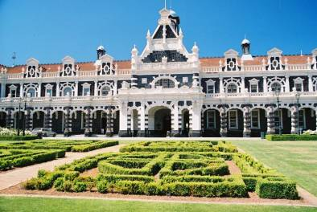The Dunedin urban a rea lies on the central-eastern coast of Otago, surrounding the head of Otago Harbour. The harbour and hills around Dunedin are the remnants of an extinct volcano. The city suburbs extend out into the surrounding valleys and hills, onto the isthmus of the Otago Peninsula, and along the shores of the Otago Harbour and the Pacific Ocean.

The city's largest industry is tertiary education – Dunedin is home to the University of Otago, New Zealand's first university (1869), and the Otago Polytechnic. Students account for a large proportion of the population: 21.6 percent of the city's population was aged between 15 and 24 at the 2006 census, compared to the New Zealand average of 14.2 percent.

Nelson

The City of Nelson is the administrative centre of the Nelson region. The population is about 60,500 people. Nelson received its name in honour of the Admiral Nelson. Nelson is a centre for arts and crafts, and each year hosts popular events such as the Nelson Arts Festival.

Nelson is a city on the eastern shores of Tasman Bay, and is the economic and cultural centre of the Nelson-Tasman region. Established in 1841, it is the second oldest settled city in New Zealand and the oldest in the South Island.

Nelson received its name in honour of the Admiral Horatio Nelson who defeated both the French and Spanish fleets at the Battle of Trafalgar in 1805. Many of the roads and public areas around the city are named after people and ships associated with that battle and Trafalgar Street is the main shopping axis of the city. Inhabitants of Nelson are referred to as Nelsonians.

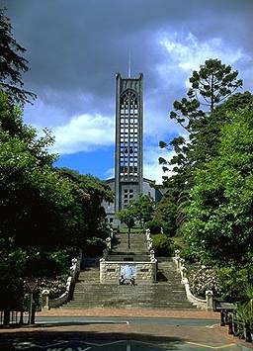Together with the town of Richmond, the Nelson Urban Area has a population of around 60,000 ranking it as New Zealand’s 9th most populous city and the geographical centre of New Zealand.

Nelson is well known for its arts and crafts, and each year hosts popular events such as the Nelson Arts Festival. The annual Wearable Art Awards began near Nelson and a museum, World of Wearable Art, is now housed close to Nelson Airport showcasing winning designs.

Nelson's Māori name, Whakatū means 'build', 'raise', or 'establish'. Nelson is one of the few New Zealand cities to have its own flag.

Nelson township was managed by the Nelson Provincial Council through a Board of Works constituted by the Provincial Government under the Nelson Improvement Act 1856 until 1874. It was proclaimed a Bishop's See and city under letters patent by Queen Victoria on 27 September 1858, the second New Zealand city proclaimed in this manner after Christchurch. Edmund Hobhouse was the first Bishop. The Municipal Corporations Act 1876 stated that Nelson was constituted a city on 30 March 1874.

Queenstown

Queenstown is a picturesque tourist destination located in the South Island. The population of the Queenstown is 9,251. The town is built around an inlet on Lake Wakatipu. Queenstown is the adventure capital of the world. Many tourists flock to the area year round to indulge in activities such as white water rafting, kayaking, jet boating, tandem sky-driving.

Queenstown is a resort town in Otago in the south-west of New Zealand's South Island. It is built around an inlet called Queenstown Bay on Lake Wakatipu, a long thin Z-shaped lake formed by glacial processes, and has spectacular views of nearby mountains. William Gilbert Rees, along with fellow explorer Nicholas Von Tunzelman, were the first Europeans to settle the area. Rees was in search of pastoral land, and after an initial visit returned in 1860 to establish a high country farm in the location of Queenstown's current town centre. However the Rees’ farming lifestyle was to be short-lived. In 1862 gold was discovered in the Arrow River, a short distance from Queenstown at which point Rees converted his wool shed into a hotel named the Queen's Arms, now known as Eichardt's.

There are various apocryphal accounts of how the town was named, the most popular suggesting that a local gold digger exclaimed that the town was "fit for Queen Victoria". It is now known for its commerce-oriented tourism, especially adventure and ski tourism. It is popular with young international and New Zealand travellers alike.

The town is the largest centre in Central Otago, and the third largest in Otago. According to the 2006 census, the usually resident population of the Queenstown urban area (including Fernhill, Frankton and Kelvin Heights) is 10,416, an increase of 22.1% since 2001.

Its neighbouring towns include Arrowtown, Wanaka, Alexandra, and Cromwell. The nearest cities are Dunedin and Invercargill.

The Queenstown-Lakes District has a land area of 8,704.97 km² (3,361.01 sq mi) not counting its inland lakes (Lake Hawea, Lake Wakatipu, and Lake Wanaka). It has an estimated resident population of 28,700 (June 2011 estimate).

Picton

Picton is the gateway to the South Island. The town's main purpose is to cater for the travellers who arrive or depart the ferry service that runs between both the North and South islands. Picton is a small town, but is busy as travellers prepare to explore the area or strike out further a field to the nearby Nelson or Canterbury regions. The population is about 4,200 people.

Picton is a town in the Marlborough region of New Zealand. It is close to the head of Queen Charlotte Sound near the north-east corner of the South Island. The population was 2928 in the 2006 Census, a decrease of 72 from 2001. The town is named after Sir Thomas Picton, the Welsh military associate of the Duke of Wellington, who was killed at the Battle of Waterloo.

Inter-island ferries to and from Wellington arrive and depart here by way of the Marlborough Sounds. Most of the sheltered part of the route is through Tory Channel, south of Arapawa Island. The township of Waikawa is a couple of minutes' drive from Picton, practically part of the same town. Waikawa boasts a marina, one of the largest in New Zealand.

As of 2001, the unemployment rate in Picton was 4.3%, compared with 7.5% for all of New Zealand.

Stewart island

New Zealand’s 3rd largest island, Stewart Island is a very special place. The only town is Oban with population about 400 people. It is a heaven for native birds’ life. The kiwi, rare in both the North and the South Island, is common over much of the island, particularly around beaches. The weather is changeable on the island. Tramping the many tracks, see kayaking, fishing, walking on the bird sanctuary, Ulva Island is some of the exiting things people can do on this island.

This hilly island with a wet climate has an area of 1 746 km². The north is dominated by the swampy valley of the Freshwater River. The river rises close to the northwestern coast and flows southeastwards into the large indentation of Paterson Inlet. The highest peak is Mount Anglem (979 metres (3,212 ft)), close to the northern coast it is one of a rim of ridges that surround Freshwater Valley.

The southern half is more uniformly undulating, rising to a ridge that runs south from the valley of the Rakeahua River, which also flows into Paterson Inlet. The southernmost point in this ridge is Mount Allen, at 750 metres (2,460 ft). In the southeast the land is somewhat lower, and is drained by the valleys of the Toitoi River, Lords River, and Heron River. South West Cape on this island is the southernmost point of the main islands of New Zealand.

Birds

There are some 70 species of birds found nowhere else in the world, more than a third of them are flightless, and almost a quarter of them nocturnal. Notable New Zealand birds include the Tui, Bellbird, Kiwi, Kakapo, Takahe, and Weka. New Zealand is also home to many seabirds including the Albatross, which has the longest wing span of any bird in the world. The most spectacular of all New Zealand birds was the Moa. Some Moa's reached heights of 15 feet, making them the tallest bird in the world.

New Zealand birds were, until the arrival of the first humans, an extraordinarily diverse range of specialised birds. In New Zealand, the ecological niches normally occupied by mammals as different as rodents, kangaroos and moles, were filled by reptiles, insects, or birds. The only terrestrial mammals were three species of bat (of which two survive today).

When humans arrived in New Zealand about 700 years ago this unique and unusual ecology became endangered. Several species were hunted to extinction, most notably the moa and harpagornis. The most damage however was caused by habitat destruction and the other animals humans brought with them, particularly rats (the Polynesian rat or kiore introduced by Māori and the Brown Rat and Black Rat subsequently introduced by Europeans), but also mice, dogs, cats, stoats, weasels, pigs, goats, deer, hedgehogs, and Australian possums. The flightless birds were in particular danger. Consequently many bird species became extinct, and others remain critically endangered. Several species are now confined only to offshore islands, or to fenced "ecological islands" from which predators have been eliminated. New Zealand is today a world leader in the techniques required to bring severely endangered species back from the brink of extinction.

During the early years of European settlement many bird species were introduced for both sport and for a connection with the settlers homelands. New Zealand had a starkly different appearance to the country or countries from where the settlers originated.

Plants

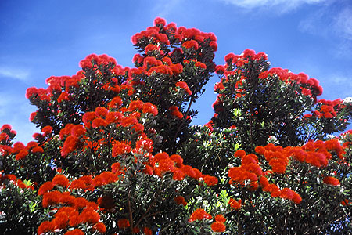New Zealand is one of the world’s richest bio-diverse flora areas on earth. It is endemic and its extent is enormous. Native trees include Rimu, Totara, Matai, Kahikatea, Rata, Tawa and many species of ferns including some giant tree ferns. Other notable trees include the Cabbage Tree, the Nikau Palm which is New Zealand's only palm tree, and the Giant Kauri, which hold the record for the greatest timber volume of any tree. One of the most noticeable plants is the Pohutukawa which detonates with brilliant red flowers around December.

New Zealand's geographical isolation has meant the country has developed a unique variety of native flora. However, human migration has led to the importation of many other plants (generally referred to as 'exotics' in New Zealand) as well as widespread damage to the indigenous flora, especially after the advent of European colonization, due to the combined efforts of farmers and specialized societies dedicated to importing European plants & animals.

While most of the world's ferns grow in tropical climates, New Zealand hosts an unusual number of ferns for a temperate country. These exhibit a variety of forms, from stereotypical feather-shaped tufted ferns and tree ferns to less typical filmy, leafy and climbing ferns. Both the koru, in the shape of an unfurling fern frond, and the silver fern are widely accepted symbols of New Zealand.

Animals

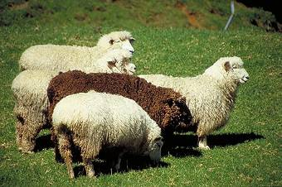

With the exception of two species of bat, no indigenous mammals are native to New Zealand. Wild mammals include deer, goats, pigs, rabbits, weasels, ferrets. Marine mammals are dolphins, seals and whales. New Zealand contains no snakes and has only one poisonous spider called the Katipo. Other insects include the Weta one species of which may grow as large as a house mouse and is the heaviest 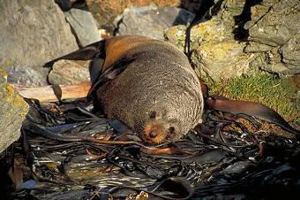insect in the world. New Zealand's most unique animal is the Tuatara, which is a lizard-like reptile that predates the Dinosaur and is considered a living fossil. 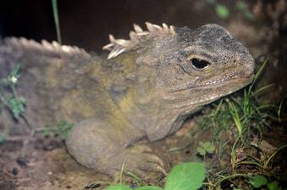

There are many animals on the isolated islands of New Zealand, including some native animals and others that have been introduced. Some of the animals native to New Zealand include: a few primitive frogs, two species of bats, a few reptiles. The only poisonous animal native to New Zealand is the katipo, a red-black spider, one of the deadliest spiders in the world. There are no snakes native to New Zealand. Many of New Zealand's native species are on the decline and some, like the kakapo, are on the verge of extinction in, yellow-eyed penguin, spotted shag, white-faced heron, blue duck, weka.

Literature:

1) "New Zealand's National Anthems". Ministry for Culture and Heritage. Retrieved 17 February 2008.

2) "Protocol for using New Zealand's National Anthems". Ministry for Culture and Heritage. Retrieved 17 February 2008.

3) "QuickStats About Culture and Identity: Languages spoken". Statistics New Zealand. March 2006. Retrieved 20 February 2008.

4) Didham, Robert; Potter, Deb (April 2005). Understanding and Working with Ethnicity Data. Statistics New Zealand. ISBN 9780478315059. Archived from the original on 25 November 2007. Retrieved 19 September 2010.

5) "The New Zealand Land Cover Database". New Zealand Land Cover Database 2. New Zealand Ministry for the Environment. 1 July 2009. Retrieved 26 April 2011.

6) "National Population Estimates: September 2011 quarter". Statistics New Zealand. 14 November 2011. Retrieved 15 November 2011.

7) "QuickStats About New Zealand's Population and Dwellings: Population counts". 2006 Census. Statistics New Zealand. Retrieved 14 April 2011.

8) "New Zealand". International Monetary Fund. Retrieved 2011-01-29.

9) "Equality and inequality: Gini index". Human Development Report 2009. United Nations Development Programme. Retrieved 14 April 2011.

Рецензия

Ученик 9 «А» класса Романов Дмитрий Петрович представил реферат по английскому языку на тему «Новая Зеландия», цель рецензируемой работы состоит в том, чтобы ученики хоть и в наименьшей степени, но были знакомы с Новой Зеландией.

Структура работы организовывалась с соблюдением всех требований, предъявляемых к содержанию и оформлению реферата.

Во введении ученик обозначил предмет и объект исследования, поставил цель и задачи, а также указал актуальность и научную новизну исследования.

В первом разделе раскрывается вопрос о том, где находится данная страна и, что собой представляет ее местонахождение. В последующих разделах говорится о том, чем богата и прекрасна Новая Зеландия.

В заключении сделаны выводы, которые соответствуют поставленным задачам. Изложенный материал отличается простотой изложения, логичностью, аргументированностью и представляет собой тесное сочетание теоретических сведений и конкретно принятых на практике решений.