Sightseeing holiday

**Level:** beginner  
**Time:** 45 mins  
**Lesson type:** Speaking and vocabulary  
**Number of students:** 1- 10  
**Materials:**pictures of different cities (optional, for offline classes)  
worksheet or virtual classroom

1.Warm-up 5 mins

Aims: to break the ice and foster a safe environment for learning.

Procedure: Introduce the topic. Ask student(s) what is sightseeing holiday and if they like it. Details are not important at this point.

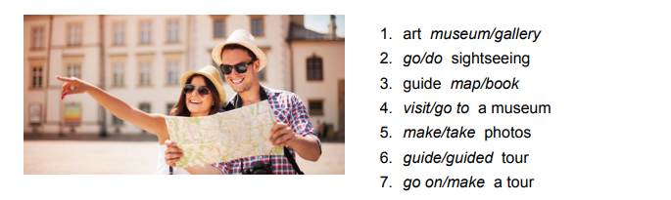

2. Choose the correct word? (Activity 1) 5 mins

Aims: to generate interest in the topic and revise the vocabulary.

Procedure: Explain that these words go together and ask to choose the correct word. Ask the students to read the words again after the teacher.

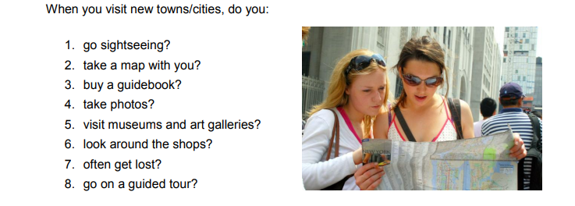

Key: 1. art gallery 2. go sightseeing 3. guide book 4. visit a museum 5. take photos 6. guided tour 7. go on a tour

3. Answer the questions. Give more detail. (Activity 2) 15 mins

Aims: to provide speaking practice..

Procedure: Elicits answers to these questions. Encourage other students to ask questions for more details. In this case the teacher should remind how to make questions in Present Simple

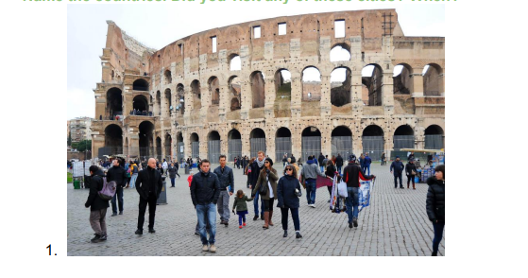

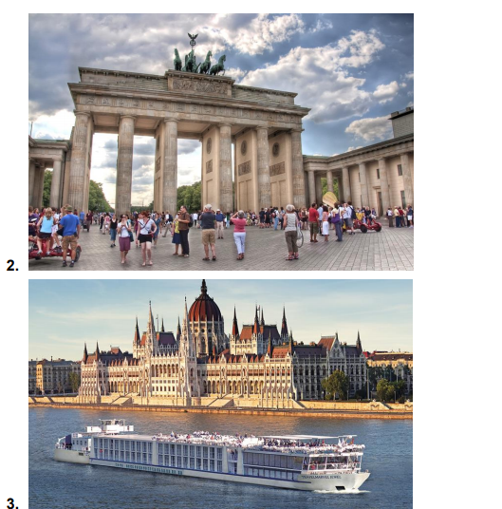

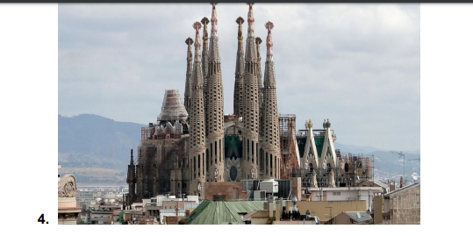

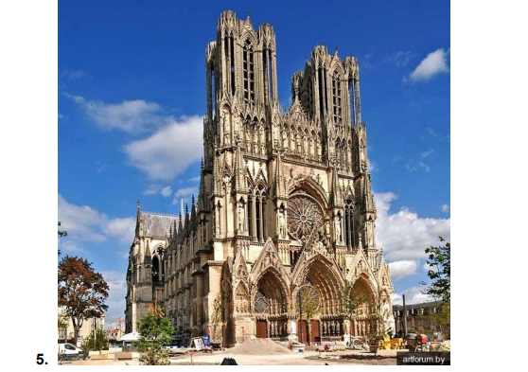

Key: student(s)’ own answers.

4.Name the countries (Activity 3) 5 mins

Aims: to provide speaking practice and develop speaking for fluency.

Procedure: Student(s) should guess what country it is. Don’t tell the correct answer until all students make their guesses. Ask what cities they have visited and when. If you work one-to-one, comment on your student’s answers and express your opinion.

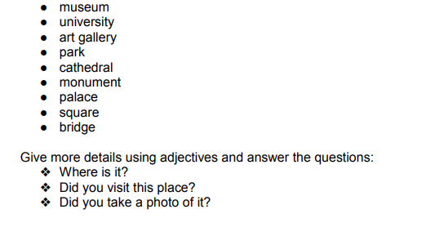

Key: A- Rome [rəʊm] B- Berlin C- Paris [ˈpærɪs] D- Budapest [ˌbjuːdəˈpɛst] E- Barcelona

5. Discussion. (Activity 4) 8 mins

Aims: to provide student(s) with practice to speak for fluency.

Procedure: Elicit the examples. The student(s) can give more details about this sight. If they haven’t been to this place, they can say if they want to go there.

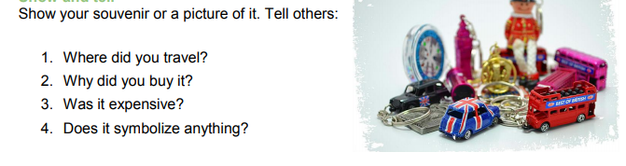

Possible answers: museum - Madame Tissot's, the Louvre university -Oxford University, Princeton University, Chernivtsi University. art gallery - Tate Modern in London park - Central Park in NY, Park Guell in Barcelona cathedral - Notre Dame in Paris monument- The statue of Admiral Nelson in London palace- Pena National Palace in Portugal, Schonbrunn Palace in Vienna square-the Piazza San Marco in Venice, the Main Market Square (Rynek Główny ) in Kraków bridge - Golden Gate in San Francisco

6. Show and tell. (Activity 5) 7 mins

Aims: to provide speaking practice.

Procedure: Elicits answers to these questions. The students should describe souvenirs using the questions. The teacher can give a model of the answer. He/she should show a thing which he/she want to describe.

6.Sum up 5 mins Put errors on the board or whiteboard and let student(s) correct them. Summarise the lesson and tell student(s) what results they have achieved (Now you can … After our speaking lesson you will be able to….) Ask students if they have any questions.